# 6th Testing – 10th May

Story 10: Open my Picture File

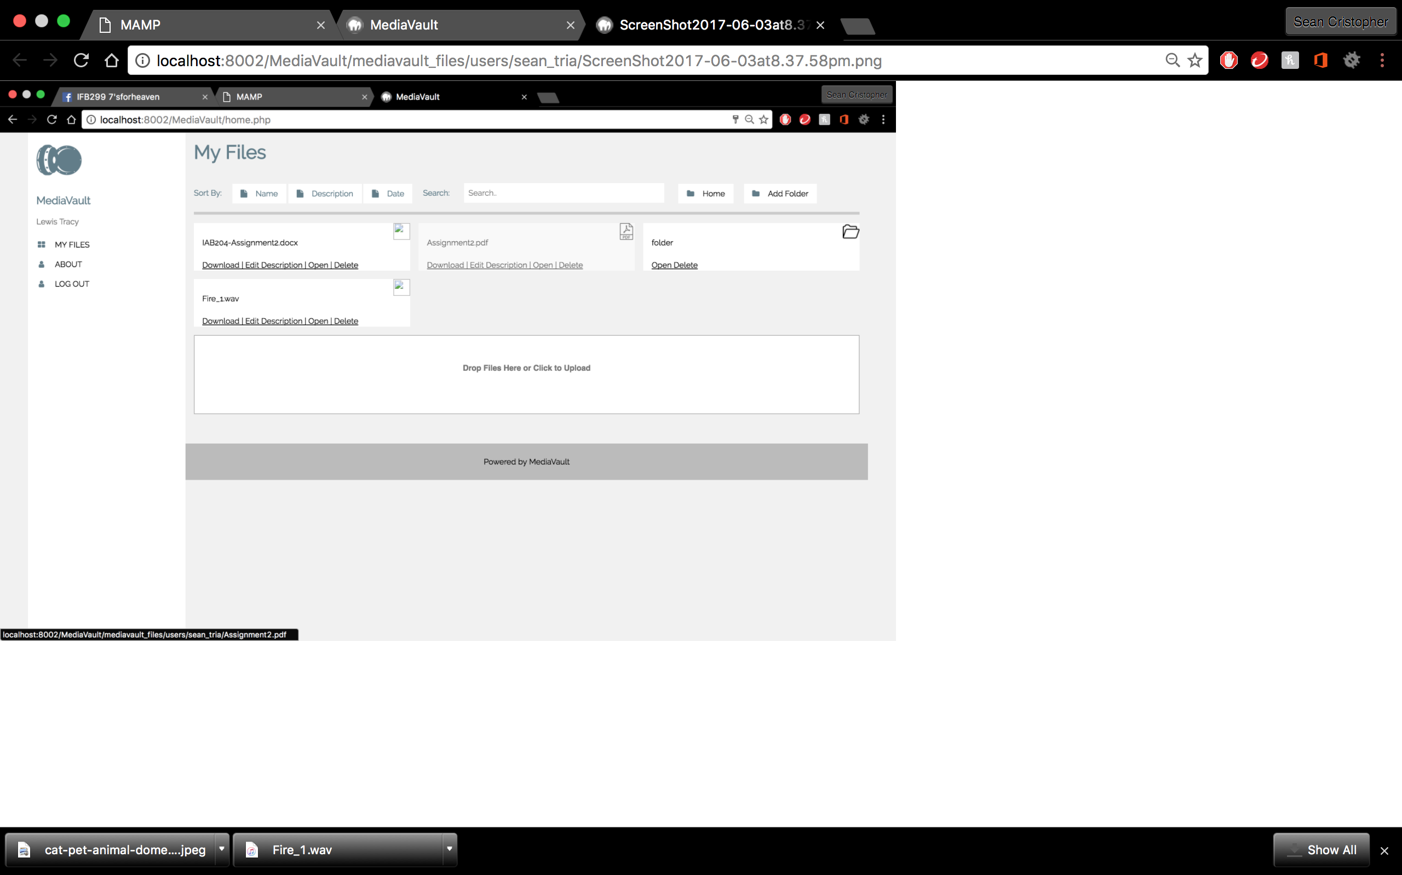

* “Open” button is independent for each file/folder
* PDF files successfully open on browser

Story 10B: Open my Folder

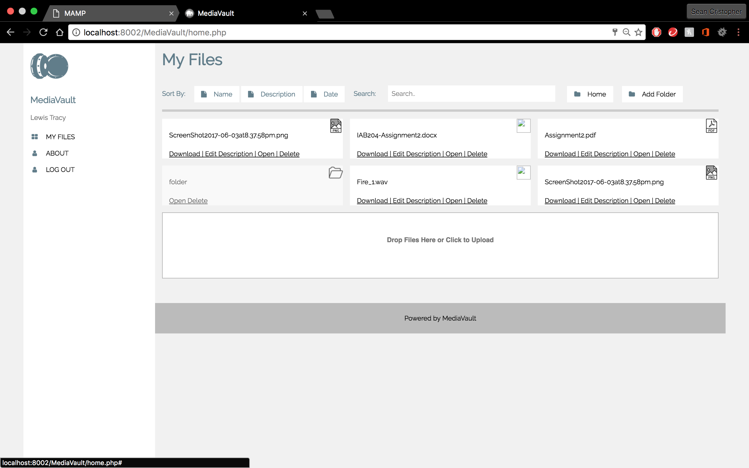

* “Open” button is independent for each file/folder
* Folder create successfully opens

Story 14: Add/Edit Meta Data to Uploaded File  
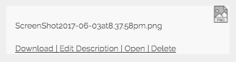

* Button “Edit Description” is added

Summary: Testing was successful and user stories were working.